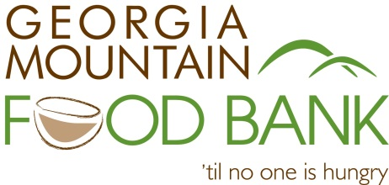
Dear Student:

The mission of the Georgia Mountain Food Bank (GMFB) is to "address hunger, health and quality of life by serving those in need.” Since 2008, the GMFB has worked to accomplish that mission through distribution of over 35 million pounds of food and grocery products to more than 66 partner agencies with hunger relief programs in five North Georgia counties!
This summer, to further our mission, we are offering a 4-day session of the GMFB Youth Summit on Hunger and Poverty: “Healthy Fresh” at the GMFB facility in Gainesville, Georgia.

If you will be in the 9th through 12th grade in 2018-19, have an interest in hunger/poverty issues, are committed to service, and are interested in taking action within your own community, then this program is for you!
As a part of the Youth Summit on Hunger & Poverty, you will:
- Gain in-depth knowledge about local and national hunger & poverty issues.
- Participate in service projects, and learn about other community and government responses to hunger and poverty.
- Identify and commit to a minimum of one hunger fighting action step in the coming school year.
- Enhance your college resume or job application.
- Receive 24+ community service hours.
- Meet other students and make new friends.
The Youth Summit on Hunger and Poverty in Gainesville at Georgia Mountain Food Bank will be held:
Monday-Thursday, June 18-21, 2018 from 9:00 a.m. to 3:30 p.m.
Participants MUST be available for the entire four day program in order to be eligible. (There are no fees or costs for participants.)
Please complete the enclosed application and tell us why you would like to participate in our Youth Summit. Contact us at (770) 534-4111; extension 208 or phil@gamountainfoodbank.org if you have any questions!
Please return your completed application, postmarked no later than Friday, March 30, to:
Youth Summit on Hunger and Poverty
Georgia Mountain Food Bank
1642 Calvary Industrial Drive SW, Gainesville, Georgia 30507
You can also fax or email your application to:
Fax: (770) 534-1800 or Email: phil@gamountainfoodbank.org

We look forward to receiving your application!

In Service,

Phil Dennis Kay Blackstock
Community Engagement Coordinator Executive Director

