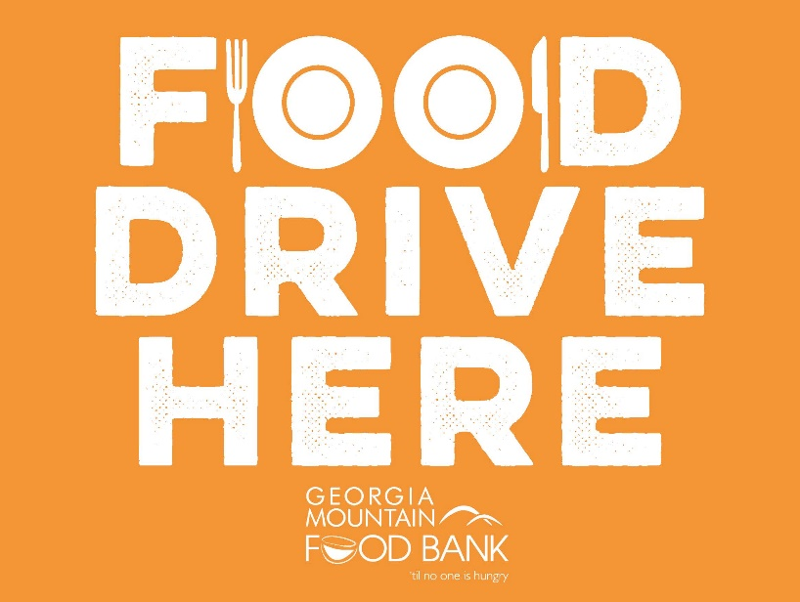
GEORGIA MOUNTAIN FOOD BANK MOST NEEDED ITEMS

Canned Meat or Fish
Tuna and other canned meat, such as chicken, stew, chili, salmon or corned beef – packed in water, low sodium/sugar

Soup/Canned Meals - Low sodium/sugar

Canned Fruits and Vegetables (i.e. black beans) - Low sodium/sugar

Peanut Butter AND Jelly - Low sodium/sugar

Pasta
Brown Rice, Pasta or boxed pasta dinners – whole grain

Milk Products – powdered or shelf stable milk

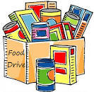
Cereal – low sugar; Oatmeal – instant or regular

Baby Diapers in all sizes

