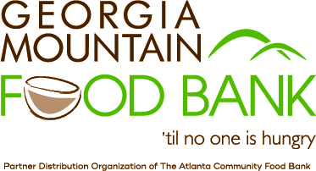
Most Wanted Food Items
Low sodium canned vegetables
No sugar added canned fruit
Canned meats & seafood
Nuts and nut butters, especially low-sugar or no-sugar options
Low sugar jams and jellies
Whole grain pasta and rice
Whole grain cereal and oats
Dried beans, peas and lentils
Other nutritious foods (preferably healthy, whole grain, low-sodium and low-sugar products)

COVID-19 Specific Hygiene Items
As we respond to COVID-19 related needs in our community, we are in need of the following items:
Hand soap
Hand sanitizer
Tissues, especially portable tissue packets
Household disinfectant products including sprays, bleach, and detergent
Household cleaning supplies

